Error Correction Encoder & Decoder | Digital Design and Logical Synthesis for Electric Computer Engineering
Error Correction Encoder & Decoder | (36113611)  Course Project  Verification  Version 3.0

Revision Log
Rev | Description | Done By | Date
0.1 | Initial document | Refael Ben Maor  Tal Kapelnik | 2.12.21
0.2 | Digital Changes | Refael Ben Maor  Tal Kapelnik | 14.12.21
0.3 | Functional Verification | Refael Ben Maor  Tal Kapelnik | 23.12.21
0.4 | Synthesis | Refael Ben Maor  Tal Kapelnik | 30.12.21

Table of Content
1. LISt of figures 2
2. List of tables 2
3. INTRODUCTION 3
3.1 Design Constraints Requirements 3
3.2 The Used Constraints 4
4. REPORTS & RESULTS of synthesis flow 6
4.1 Synthesis Flow 6
4.2 Area Report 6
4.3 Timing Report 8
4.4 Power Report 10
4.5 Constraints Violations 11
4.6 Check Design 12
5. Appendix 13
5.1 Terminology 13

LISt of figures
Figure 1: Area Report 7.5ns 6
Figure 2: Area Report 10ns 7
Figure 3: Timing Report 7.5ns 8
Figure 4: Timing Report 10ns 9
Figure 5: Power Report 7.5ns 10
Figure 6: Constraints Report 11
Figure 7: Check Design Report 12

List of tables
Table 1: Design Constraints Requirements. 3
Table 2: Used Constraints 4

INTRODUCTION

Design Constraints Requirements
Initial system constraints to use in the synthesis flow are as follows:

Constraint Type | Value
Clock Period | At least 100KHz
Clock uncertainty | Maximum 0.1 ns
Clock transition time | Maximum 0.1 ns
Input delay | Maximum 0.2 ns
Input transition | Maximum 0.1 ns
Output delay | Maximum 0.5 ns
Design area | Smaller than 50,000,000
Wire load model | tsmc18_wl50
- Design Constraints Requirements.

The Used Constraints

False Path
From Pin/Port | Through Pin |  | To Pin/Port | Comments
Clock Definitions
Constraint Name |  | CLK |  |  | Comment
Period [Nano Seconds]
Pin/Port name |  | clk
Uncertainty
Transition
External Delay [Nano Seconds]
Pin name |  | Value |  |  | Comment
All pins
- Used Constraints

REPORTS & RESULTS of synthesis flow

Synthesis Flow
Synthesis done by these steps:
- Using the Ubuntu to use the DC program
- Writing the Synthesis.tcl in Tcl for the setup and constrains
- Move the RTL files into the DC folder
- Compiling the program via dc_shell
- Using the report output files for further analyze

Area Report
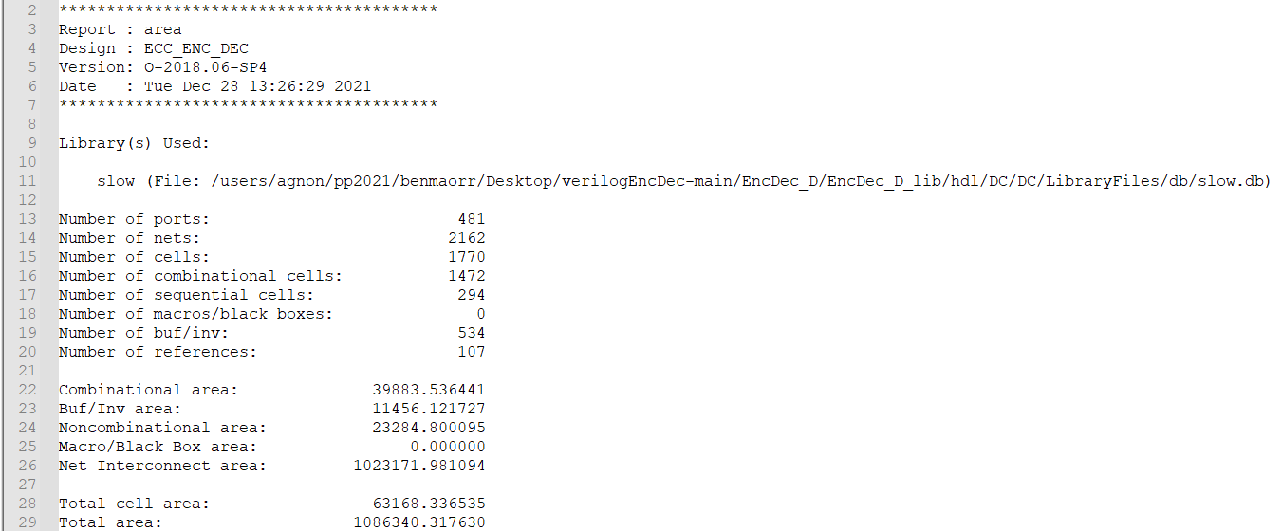
- Area Report 7.5ns
As we can see, The DUT stands with the assignment constraints. The area limit was 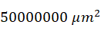, and out DUT turned out to be 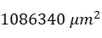 which is 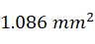.
If we need a smaller design, we can make our clock slower than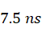, which is the minimal clock this DUT can handle, for example if we take clock with period of 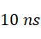 we get this report -

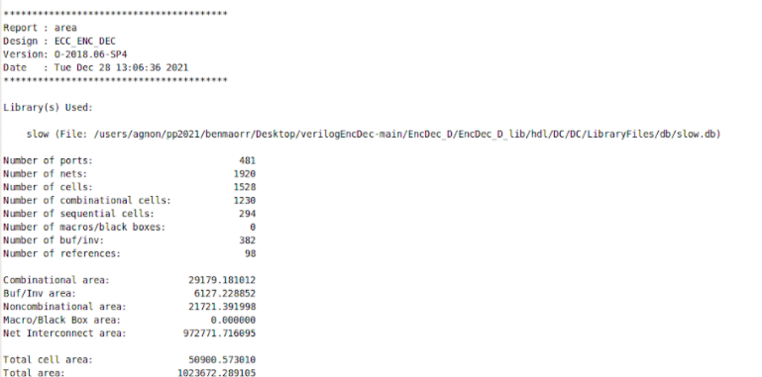
- Area Report 10ns
As we can see we saved 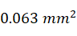 area by just changing the clock period to a slower frequency.

Timing Report
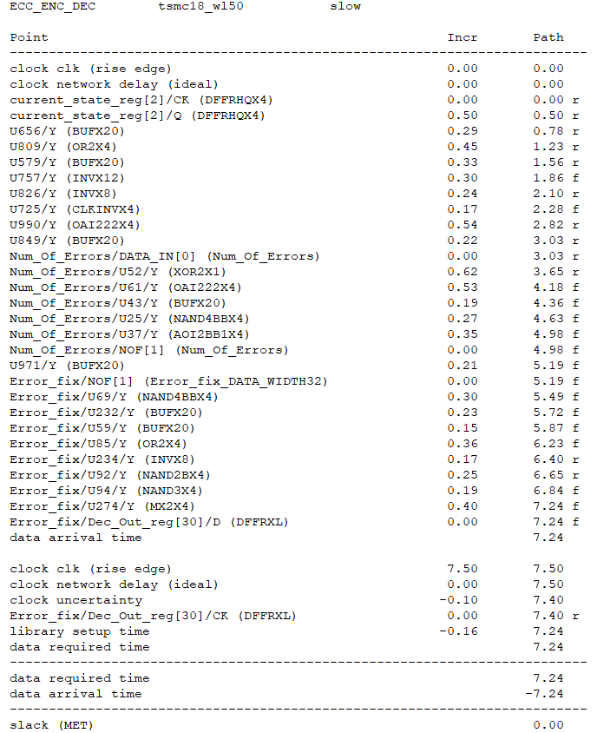
- Timing Report 7.5ns
From this timing report, we show the lowest period of clock that we can have in our design before we are getting negative slack. With this period, we get the critical path in the image above. We can make our period faster, if we will improve this critical path.
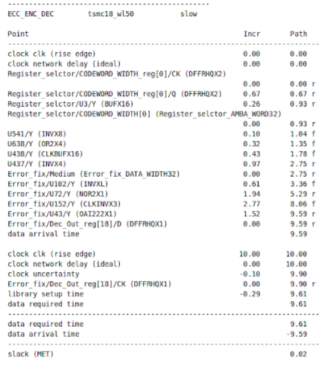
- Timing Report 10ns
We did also try a period of 10 ns, for compering between two periods. As we can see, the critical path got shorter but took longer, and we also got positive slack, which says that we do not have good constrain and we can improve it.

Power Report
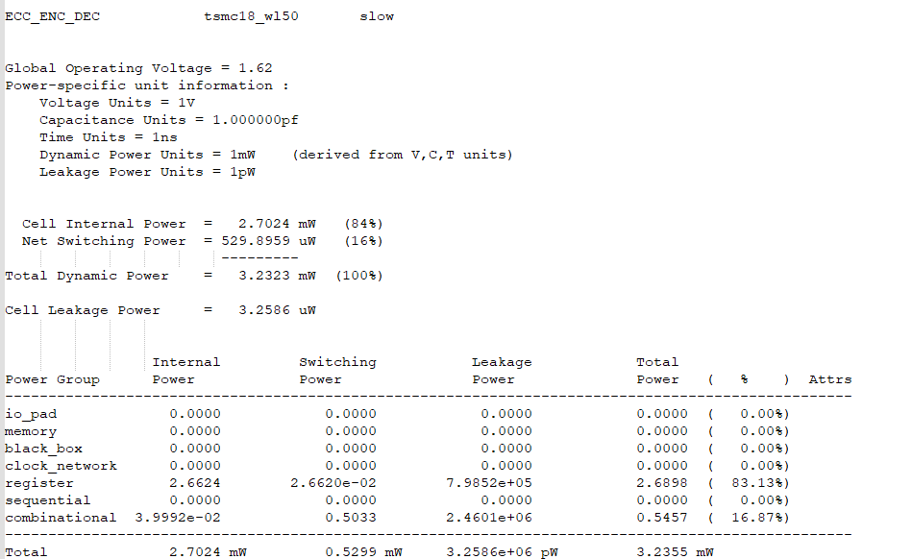
- Power Report 7.5ns
As we can see most of our power is going to the registers, what can tell us if we want better performance, we need to improve them by for example by clock gating, to prevent unnecessary toggling. For example in our design we can use clock gating on the main state machine.

Constraints Violations
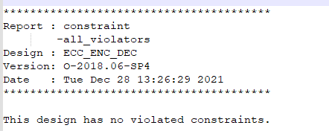
- Constraints Report
In our design we did not get any violations.

Check Design
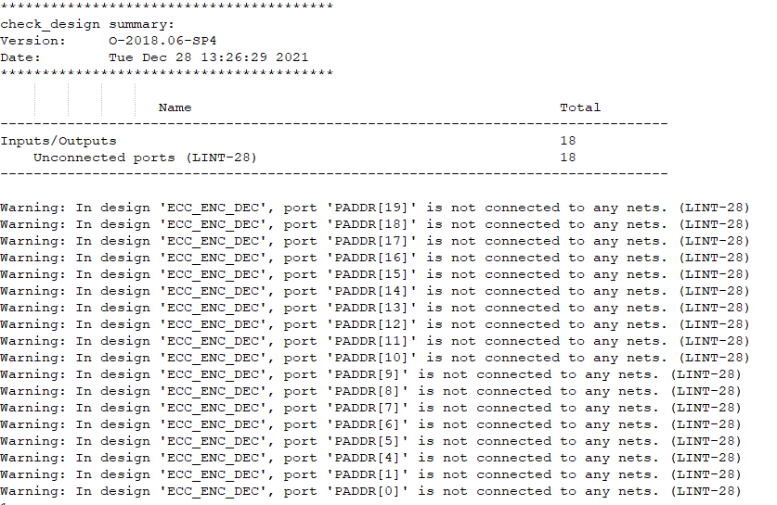
- Check Design Report
As we can see we got only warning about the unconnected PADDR. The reason is that we use only the PADDR[3:2] bits in our design, we don’t need the rest of the bits, because they not effective for the functionality, its only for a purpose of reading/writing.

Appendix

Terminology
LSB - Least Significant Bit
TBR - To Be Reviewed
TBD - To Be Defined
IF - Inteface
DUT - Device Under Test
GM - Golden Model
tb - Test Bench

